

Tribhuvan University
Faculty of Humanities and Social Sciences

PATIENT RECORD KEEPING SYSTEM
A PROJECT REPORTS

Submitted to
Department of Computer Application
Butwal Kalika Campus
In partial fulfilment of the requirements for the Bachelor in Computer Application

Submitted by
Anmol Chhetri(6-2-1055-142-2023)
Dinesh Lamichhane(5-2-1134-3-2015)
Falgun, 2082 B.S.
Under the Supervision of
Bhuban Panthee

Tribhuvan University
Faculty of Humanities and Social Sciences
Butwal Kalika Campus

SUPERVISOR’S RECOMMENDATION

I hereby recommend that this project prepared under my supervision by Anmol Chhetri and Dinesh Lamichhane entitled “PATIENT RECORD KEEPING SYSTEM” in partial fulfillment of the requirements for the degree of Bachelor of Computer Application is recommended for the final evaluation.

………………..
SIGNATURE OF SUPERVISOR
Bhuban Panthee
Lecturer
Department of Computer Application
Butwal-10, Rupandehi



Tribhuvan University
Faculty of Humanities and Social Sciences
Butwal Kalika Campus

LETTER OF APPROVAL

This is to certify that this project prepared by Sikhar Panthi and Sachin Pandey entitled “Online Food Ordering System” in partial fulfillment of the requirements for the degree of Bachelor in Computer Application has been evaluated. In our opinion, it is excel- lent and is satisfactory in the scope and quality as a project for the required degree.
SIGNATURE of Supervisor  . . . . . . . . . . . . . . . . . . . . . . . . . . . . . . . . . . . . .  Roshan Khanal Lecturer  Department of Computer Application | SIGNATURE of Campus Chief  . . . . . . . . . . . . . . . . . . . . . . . . . . . . . . . . . . . . .  Ghanshyam Pathak Campus Chief  Butwal Kalika Campus
SIGNATURE of Coordinator | SIGNATURE of External Examiner
. . . . . . . . . . . . . . . . . . . . . . . . . . . . . . . . . . . . .  Coordinator  Department of Computer Application Butwal Kalika Campus | . . . . . . . . . . . . . . . . . . . . . . . . . . . . . . . . . . . . .  Lecturer  Department of Computer Application Butwal Multiple Campus

STUDENT’S DECLARATION

We hereby declare that the project work entitled “Patient Record Keeping System” sub- mitted to the Department of Computer Application, Butwal Kalika Campus, is our original work and has been completed under the supervision of Bhuban Panthee. This project has not been submitted to any other university or institution for the award of any degree or diploma.

We take full responsibility for the content and originality of this project work.

. . . . . . . . . . . . . . . . . . . . . . . . . . . . . . . . . . . . . . . . . . . . . . . . . . . . . . . . . . . .
Anmol Chhetri Dinesh Lamichhane
6-2-1055-142-2023 5-2-1134-3-2015

SUPERVISOR LOG SHEET

ABSTRACT
The Patient Record Keeping System is a web-based platform designed to simplify and modernize healthcare record management. It enables administrators to manage patient details, assign doctors, schedule appointments, generate reports, and handle billing—all from a single dashboard. Doctors can view their assigned patients, manage schedules, and update medical records through a dedicated interface. The system uses Next.js for the frontend, providing a fast, responsive, and SEO-friendly user experience. The backend is powered by Express.js, and data is stored in MongoDB, ensuring scalability and flexibility for complex healthcare data. This architecture supports secure authentication, role-based access control, real-time updates, and efficient CRUD operations. By digitizing patient records and workflows, the system reduces manual errors, saves time, and enhances overall healthcare service delivery.
Keywords: Patient Record Keeping System, Web-Based Application, Next.js, Express.js, MongoDB, Role-Based Access Control, Appointment Scheduling, Secure Authentication.

ACKNOWLEDGMENT
We would like to sincerely thank everyone who contributed to the successful completion of our project, Patient Record Keeping System. First and foremost, we express our heartfelt gratitude to our supervisor, Bhuban Panthee, for his invaluable guidance, constructive feedback, and continuous encouragement throughout the development process. His expertise and insights were instrumental in shaping and completing this work successfully. We are also deeply grateful to Butwal Kalika Campus and the Department of Computer Applications for providing us with the resources, opportunities, and a supportive environment that enabled us to turn our ideas into reality. Finally, we recognize and appreciate the dedication and collaboration of our project team. The teamwork, perseverance, and shared efforts were crucial in bringing this project to completion. Thank you all for your contributions and for being a part of this journey with us.

TABLE OF CONTENTS
SUPERVISOR’S RECOMMENDATION ii
LETTER OF APPROVAL iii
STUDENT’S DECLARATION iv
SUPERVISOR LOG SHEET v
ABSTRACT vi
ACKNOWLEDGEMENT vii
LIST OF ABBREVIATIONS x
LIST OF FIGURES xi
LIST OF TABLES xii
CHAPTER 1: INTRODUCTION 1
1.1. Introduction 1
1.2. Problem Statement 1
1.3. Objectives 2
1.4. Scope 2
1.6. Report Organization 3
CHAPTER 2: BACKGROUND STUDY AND LITERATURE REVIEW 4
2.1. Background Study 5
2.2. Literature Review 6
CHAPTER 3: SYSTEM ANALYSIS AND DESIGN 6
3.1. System Analysis 7
3.1.1. Requirement Analysis 7
3.1.2. Feasibility Analysis 9
3.1.3. Data Modeling (ER-Diagram) 10
3.1.4. Process Modeling (DFD) 11
3.2. System Design 12
3.2.1 Architectural Design 12
3.2.2. Database Schema Design 13
3.2.3. Interface Design 14
3.2.4. Physical DFD 14
CHAPTER 4: IMPLEMENTATION AND TESTING 16
4.1. Implementation 16
4.1.1. Tools Used 16
4.1.2. Implementation Details of Modules 16
4.2. Testing 17
4.2.1. Test Cases for Unit Testing 17
4.2.2. Test Cases for System Testing 18
CHAPTER 5: CONCLUSION AND FUTURE RECOMMENDATIONS 19
5.1. Lesson Learnt 19
5.2. Conclusion 19
5.3. Future Recommendations 20
REFERENCES 21
APPENDICES 22

List of Abbreviations
DFD | Data Flow Diagram
ER | Entity Relationship
JS | JavaScript

List of Figures
Figure 3.1: Use Case Diagram 8
Figure 3.2: ER-Diagram 10
Figure 3.3: Level 0 DFD 11
Figure 3.4: Level 1 DFD 12
Figure 3.5: Database schema 14

List of Tables
Table 4.1: Tools Used 16
Table 4.2: Unit Test Cases for Patient Recording System 17
Table 4.3: System Test Cases for Patient Recording System 18

CHAPTER 1: INTRODUCTION

1.1. Introduction
The Patient Record Keeping System is a web-based application developed to simplify and modernize the process of managing healthcare records for clinics and hospitals. Traditionally, patient information, appointments, and medical reports were maintained manually, which often led to delays, miscommunication, and errors in record handling. This system provides a digital platform that connects administrators and doctors, enabling them to manage patient details, schedule appointments, maintain medical reports, and handle billing efficiently.
The system consists of two main components: the Admin Panel and the Doctor Dashboard. On the administrative side, admins can add patients, assign doctors, manage appointments, generate reports. The dashboard provides summaries of total patients, appointments, and reports, presented in tables for easy monitoring. On the doctor’s side, doctors can view their assigned patients, manage schedules, and update medical records.
The application is built using Next.js for the frontend, ensuring a fast, responsive, and SEO-friendly interface. The backend is powered by Express.js, and data is stored in MongoDB, providing scalability and flexibility for complex healthcare data. The system supports secure login, role-based access control, and real-time updates, making it convenient for both administrators and doctors. Overall, the Patient Record Keeping System enhances efficiency, reduces manual errors, and improves healthcare service delivery.

1.2. Problem Statement
Although digital healthcare solutions exist, many clinics and hospitals still face challenges in managing patient records efficiently. Current systems are often fragmented, lack real-time synchronization, and fail to provide a seamless experience for both administrators and doctors. These gaps lead to delays, miscommunication, and errors in patient care.
Key problems include:
i. Many healthcare facilities still rely on manual record-keeping, which is time-consuming and prone to errors.
ii. There is no unified platform for managing patient details, appointments, reports, and causing inefficiencies and confusion.
iii. Medical reports and patient histories are often scattered or poorly organized, making it difficult for doctors to access accurate information quickly.
iv. Lack of role-based access and secure authentication increases the risk of unauthorized access and data breaches.
1.3. Objectives
The objective of this project is to develop a web application that allows healthcare administrators and doctors to manage patient records efficiently and securely.
The major objectives are:
i. To develop a user-friendly platform that enables administrators to add patients, assign doctors, schedule appointments, and manage reports.
ii. To provide doctors with a dedicated dashboard to view assigned patients, manage schedules, and update medical records.
iii. To implement secure authentication and role-based access control for both administrators and doctors.
iv. To ensure real-time data updates and accurate record management using modern web technologies (Next.js, Express.js, MongoDB).

1.4. Scope
The Patient Record Keeping System is designed primarily for clinics and hospitals, with the aim of improving the efficiency and accuracy of healthcare record management. The system allows administrators to add and manage patient details, assign doctors, schedule appointments and generate medical reports—all within a single platform.
On the administrative side, the system provides full control over patient records and operational workflows, including real-time monitoring of appointments and reports. On the doctor’s side, the dashboard enables doctors to view their assigned patients, manage schedules, and update medical records securely.
The platform is built using Next.js for the frontend, Express.js for the backend, and MongoDB for data storage, ensuring scalability and flexibility. It supports secure authentication, role-based access control, and responsive design for accessibility across devices. Overall, the system seeks to reduce manual errors, save time, and enhance patient care by offering an organized and effective digital solution for healthcare record management.

1.5. Limitation
The Patient Record Keeping System is designed specifically for small to medium-sized healthcare facilities, which means its reach is limited and may not be suitable for large-scale hospital networks without further customization. The system does not currently include advanced features such as integration with national health databases, telemedicine support, or automated insurance claim processing.
Additionally, the platform depends on stable internet connectivity; any disruption in service can affect access to patient records and appointment scheduling. The system assumes that administrators and doctors have basic computer literacy, as improper use may lead to errors in data entry or management. Finally, advanced functionalities such as AI-based diagnosis assistance, predictive analytics, and multi-language support are not included in this version but can be considered for future enhancements.
1.6. Report Organization
The report is organized into five main chapters to provide a systematic and comprehensive overview of the Patient Record Keeping System. Each chapter focuses on specific aspects of the project, from background study to conclusion and recommendations.
Chapter 1: Introduction
This Present the general overview of the project, including the problem statement, objectives, scope, limitations, and report organization. This chapter establishes the purpose and significance of developing the system for healthcare facilities.
Chapter 2: Background Study and Literature Review
Provides a theoretical foundation and describes fundamental concepts, terminologies, and technologies related to the project. It also reviews similar systems and relevant research conducted by other authors to identify best practices and existing gaps.
Chapter 3: System Analysis and Design
Discusses the detailed analysis and design of the system. It includes requirement analysis (functional and non-functional), feasibility study (technical, operational, economic, and schedule), data modeling using ER diagrams, process modeling using DFDs, system architecture, database schema design (MongoDB collections), and user interface design.

Chapter 4: Implementation and Testing

Describes the tools, programming languages, and platforms used to develop the system. It also presents the implementation details of each module and the testing procedures, including unit testing and system testing, to ensure functionality and reliability.

Chapter 5: Conclusion and Future Recommendations.
Summarizes the outcomes and lessons learned from the project. It highlights the system’s contributions and provides suggestions for future enhancements and improvements.

CHAPTER 2: BACKGROUND STUDY AND LITERATURE REVIEW

2.1. Background Study
The rapid advancement of information and communication technology (ICT) has significantly transformed various sectors, including healthcare. Traditional methods of managing patient records—such as maintaining paper files and manual appointment scheduling—are often time-consuming, inefficient, and prone to errors, including misplaced records, delayed treatments, and miscommunication between administrators and doctors. As a result, there is a growing need for automated and digital solutions that can streamline healthcare processes and improve overall patient care.
Patient Record Management Systems have emerged as an effective solution to meet these demands. These systems provide a centralized platform where administrators can manage patient details, assign doctors, schedule appointments, generate medical reports, and handle billing. Doctors can access patient histories, update records, and manage their schedules conveniently from any device. Such platforms not only enhance operational efficiency but also improve the quality of healthcare services by reducing human errors and ensuring accurate, real-time data availability.
In addition, the integration of modern web technologies—such as Next.js for frontend development, Express.js for backend processing, and MongoDB for database management—has enabled the development of scalable, reliable, and user-friendly systems. These technologies ensure responsive interfaces for users and robust data handling for healthcare administrators. For small and medium-sized healthcare facilities, particularly those that lack advanced digital infrastructure, a patient record management platform provides an opportunity to improve service delivery, reduce operational inefficiencies, and meet the expectations of modern healthcare standards.

2.2. Literature Review

Several studies have been conducted to develop effective patient record management systems, aiming to enhance efficiency, security, and accessibility in healthcare. Patil et al. (2025) [1] proposed a system to streamline the storage and retrieval of patient data, reducing errors and facilitating quick access for healthcare providers. Brijwani et al. (2025) [2] explored blockchain-based solutions for secure and tamper-proof record management, ensuring controlled access and maintaining data integrity. Yuvarajan et al. (2025) [3] focused on mobile health platforms, enabling real-time updates and seamless sharing of patient records across hospital departments. Zala et al. (2023) [4] developed a cloud-based system with privacy-preserving mechanisms, combining encryption and access control to secure patient data on third-party platforms.

Collectively, these studies highlight the importance of security, accessibility, and efficiency in patient record systems and provide a foundation for developing a role-based, user-friendly PRMS suitable for modern healthcare facilities.

CHAPTER 3: SYSTEM ANALYSIS AND DESIGN
3.1. System Analysis
System analysis involves studying the requirements and structure of the Patient Record Keeping System to ensure it meets the needs of healthcare administrators and doctors. It identifies functional and non-functional requirements, evaluates technical and operational feasibility, and models data and processes to guide design. This phase ensures that the system’s architecture, database, and interface support secure, efficient, and user-friendly record management.

3.1.1. Requirement Analysis
The requirement analysis defines the features and constraints of the system. It is divided into functional requirements and non-functional requirements.
i. Functional Requirements
The main functional requirements for the Patient Record Keeping System are:
- Administrators must be able to create accounts, log in securely, and manage their profiles.
- Administrators can add, edit, and delete patient records (name, age, gender, contact details, address).
- Administrators can assign doctors to patients and manage doctor accounts.
- Administrators can schedule appointments with details such as patient name, doctor, date, time, and status.
- Doctors can log in securely and view their assigned patients.
ii. Non-Functional Requirements
- The system must provide secure authentication and role-based access control.
- The interface should be simple, intuitive, and responsive for both administrators and doctors.
- The system must ensure data integrity and confidentiality, especially for sensitive patient information.
- The application should be accessible across devices (desktop, tablet, mobile).
- The system should handle multiple concurrent users efficiently and provide real-time updates.

Use Case Diagram:

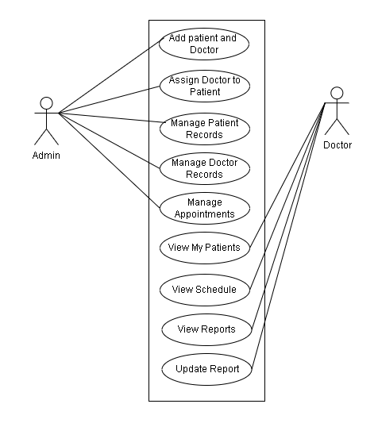

Figure 3.1: Use Case Diagram

3.1.2. Feasibility Analysis
Feasibility analysis evaluates whether the Patient Record Keeping System can be successfully developed and implemented, considering technical, operational, economic, and scheduling aspects.
- Technical Feasibility
The system uses widely accepted and reliable technologies, including Next.js for the frontend, Express.js for backend processing, and MongoDB for database management. These technologies are compatible with modern web servers and provide sufficient scalability and performance for healthcare operations. The required hardware and software resources are readily available, and the development team possesses the necessary technical skills. Therefore, the project is technically feasible.
- Operational Feasibility
The system is designed to be user-friendly, ensuring that both healthcare administrators and doctors can use it without extensive training. Administrators can easily manage patient records, appointments, while doctors can view assigned patients and update reports efficiently. The system addresses the operational challenges of manual record-keeping and improves overall workflow, making it operationally feasible.
- Economic Feasibility
The project is cost-effective as it primarily relies on open-source technologies, reducing software licensing costs. The implementation requires minimal additional hardware and can significantly reduce manual effort and errors, potentially improving patient care and operational efficiency. The benefits of time-saving, error reduction, and enhanced healthcare service delivery outweigh the development and maintenance costs, making the system economically feasible.
- Schedule Feasibility
The system can be developed and deployed within a reasonable timeframe due to its scope being limited to small and medium-sized healthcare facilities. Using modern web technologies and a clear project plan, the development team can complete the project within the scheduled period, ensuring timely delivery. Therefore, the project is schedule feasible.

3.1.3. Data Modeling (ER-Diagram)

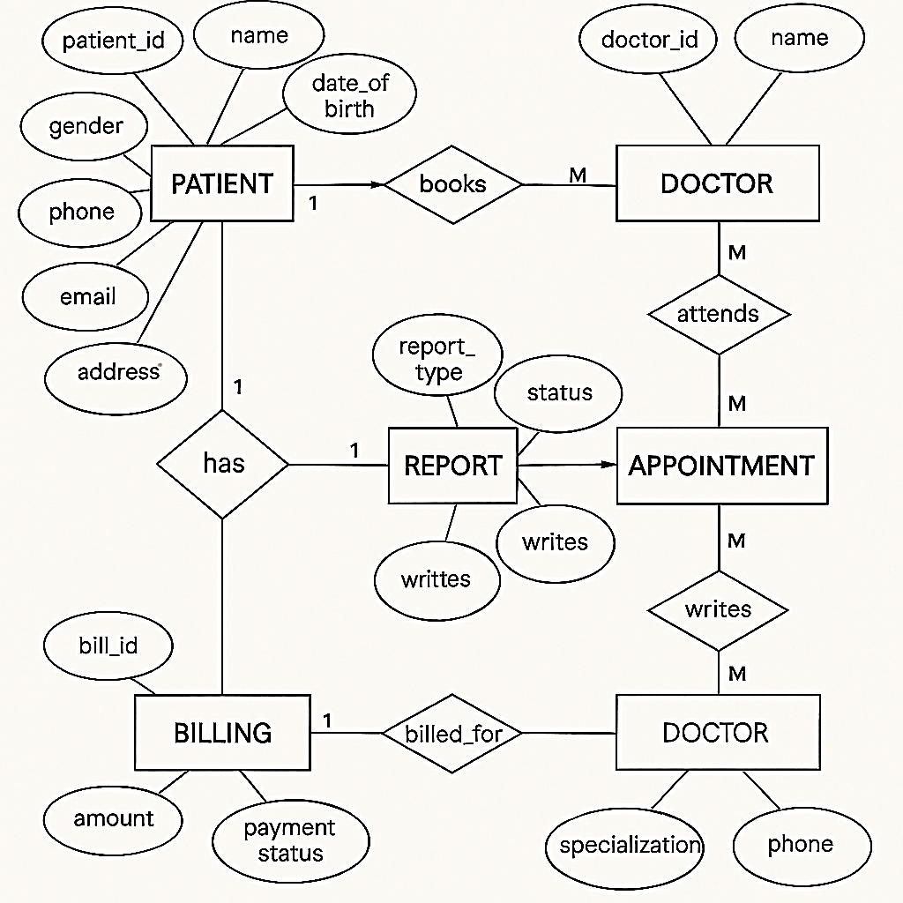

Figure 3.2: ER-Diagram

3.1.4. Process Modeling (DFD)
Process modeling illustrates how data flows through the Patient Record Keeping System. A Data Flow Diagram (DFD) is used to represent the processes, data stores, external entities, and the movement of information within the system. The DFD helps visualize how inputs are transformed into outputs and clarifies system functionality at different abstraction levels.
- Level 0 DFD (Context Diagram)
Represents the entire system as a single process interacting with external entities such as Admin and Doctor. Admin manages patients, appointments, reports, while doctors update medical records and view assigned patients.

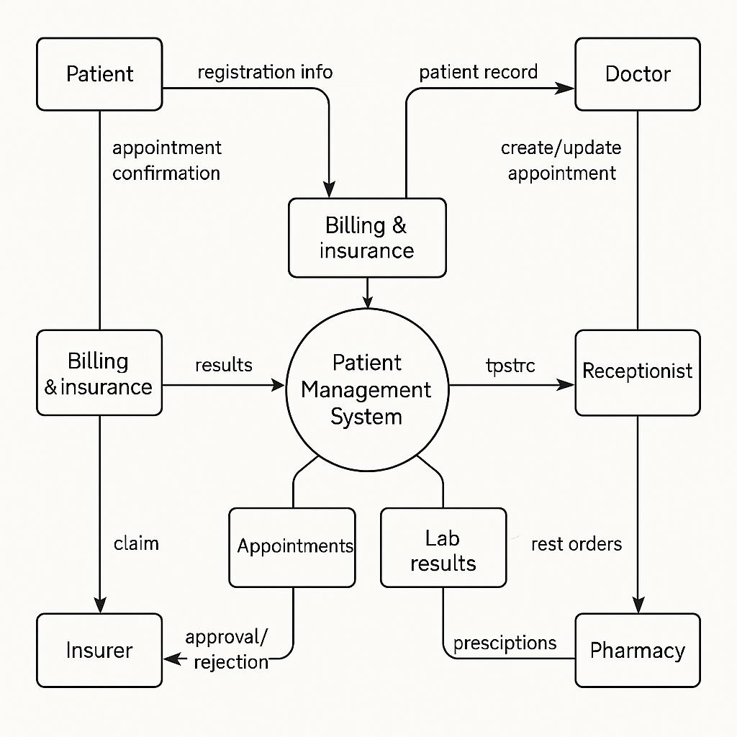

Figure 3.3: Level 0 DFD
- Level 1 DFD
Breaks down the main system into key processes such as Patient Management, Doctor Management, Appointment Scheduling and Report Handling. It shows how data flows between these processes and the database.

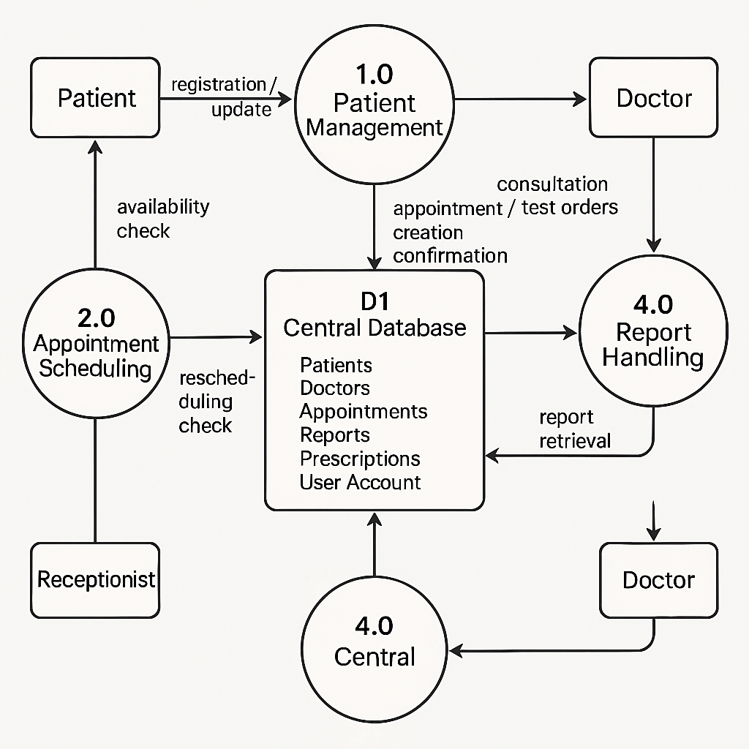

Figure 3.4: Level 1 DFD

3.2. System Design
System design defines the structure of the Patient Record Keeping System, detailing how components interact and how data flows between them. It converts requirements into a technical blueprint, including architecture, database schema, and interface design. This ensures a secure, scalable, and user-friendly solution using Next.js, Express.js, and MongoDB.

3.2.1 Architectural Design
The architecture of the Patient Record Keeping System follows a three-tier architecture, which separates the application into:
- Presentation Layer
Developed using Next.js, this layer manages the entire user interface for both administrators and doctors. It includes pages for patient management, appointment scheduling, report handling and dashboards. The frontend communicates with the backend exclusively through RESTful API requests, ensuring smooth interaction and a responsive user experience.
- Application Layer
Built using Express.js, this layer handles server-side logic such as user authentication, role-based access control, patient CRUD operations, appointment scheduling, report management, and billing processing. It validates incoming data, applies business rules, and provides structured API responses for the frontend.
- Database Layer
Implemented in MongoDB, this layer stores all persistent system data, including users, patients, doctors, appointments, reports. It ensures data integrity, supports flexible document structures, and provides scalability for healthcare operations.
3.2.2. Database Schema Design
The database for the Patient Record Keeping System is designed to store and manage all healthcare-related data efficiently. It uses MongoDB, a document-oriented database that ensures flexibility and scalability. The schema consists of collections for Users (admin and doctor credentials), Patients (personal details), Doctors (profiles and specialization), Appointments (patient-doctor schedules), Reports (medical findings). This structure supports secure storage, easy retrieval, and real-time updates for healthcare operations.

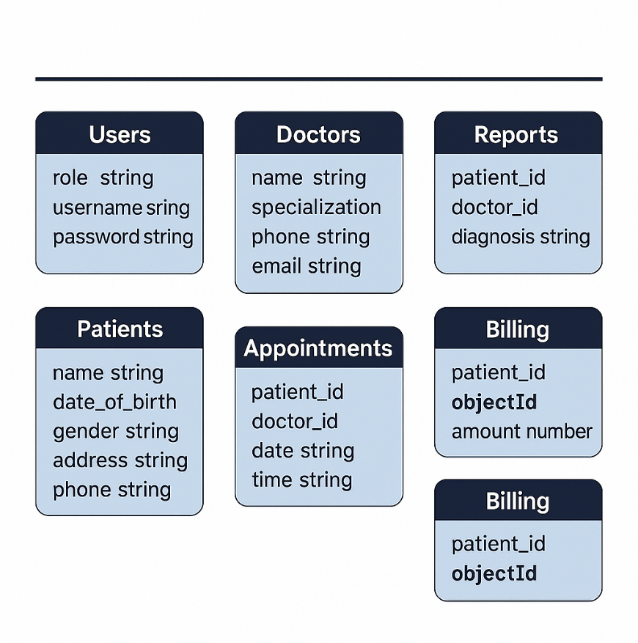

Figure 3.5: Database schema
3.2.3. Interface Design

The interface design of the Online Patient Record Keeping System focuses on providing a clear, intuitive, and user-friendly experience for both doctors and administrators. The design ensures that users can navigate the system easily, access required functionalities, and perform tasks efficiently.
- Doctor Interface
The doctor dashboard is designed to be simple and responsive. It includes sections for My Patients, Appointments, and Reports, allowing doctors to view assigned patients, manage schedules, and update medical records easily.
- Admin Interface
The admin dashboard provides full control over system operations. It includes modules for Patient Management, Doctor Management, Appointments, Reports,. The dashboard also displays summaries of total patients, upcoming appointments, and pending bills for quick decision-making.
- Interface Structure
Both interfaces follow a consistent layout with clear navigation menus, buttons, and forms. The system is responsive across desktops, tablets, and mobile devices. Validation checks, confirmation messages, and clear labels are implemented to reduce errors and improve user satisfaction.

3.2.4. Physical DFD
The Physical DFD represents how the proposed Patient Record Keeping System operates in the real environment, showing actual hardware, software, people, and physical media involved in data processing. It illustrates who performs the processes, where the processes occur, and how data flows through physical components of the system.
In this physical DFD:
- External entities such as Admin and Doctor interact with the system using physical devices like smartphones or computers.
- Processes show real-world actions performed by system modules such as Login System and Report Handling.
- Data stores represent physical/real storage such as MongoDB Database Server for storing admin details, doctor profiles, patient records, appointments, reports, and billing information
- Data flows show physical movement of data between entities entities and the system via the internet, using secure API calls between the Next.js frontend and Express.js backend.

CHAPTER 4: IMPLEMENTATION AND TESTING

4.1. Implementation

4.1.1. Tools Used
The development of the Patient Record Keeping System required a combination of programming languages, frameworks, and database platforms. The following tools and technologies were used:

Table 4.1: Tools Used

Tools Name: | Purpose:
VS Code | Used to develop and manage frontend and backend source code.
Node.js & Express.js | Provides backend environment for API development and server-side logic.
MongoDB | Stores and manages all project data such as users, patients, doctors, appointments, reports, and billing.
Git & GitHub | Version control and code hosting for project backup and deployment.

  - CASE Tools
- Draw.io: Used to design ER diagrams, use case diagrams, DFDs, and architectural diagrams.
- Git & GitHub: Used for version control, collaboration, and maintaining development history.
- Programming Languages
- Next.js (Frontend): Used to build interactive and dynamic user interfaces with server-side rendering for better performance.
- JavaScript: Used throughout the frontend for API calls, state management, and handling UI actions.
- Express.js (Backend)
- Database Platforms
- Mango DB: Used as the primary NoSQL database to store users, patients, doctors, appointments and reports details.

4.1.2. Implementation Details of Modules
The entire project mainly consists of 2 modules, which are:
- Admin Module
- Secure login and authentication
- Add, edit, view, and delete patient records
- Assign doctors to patients
- Manage appointments (schedule, update status)
- Generate and manage medical reports
- Doctor Module
- Secure login and authentication
- View assigned patients
- Manage appointments and schedules
- Update patient reports and medical findings

4.2. Testing
Testing is an essential phase of the development process to ensure the Patient Record Keeping System functions correctly, meets requirements, and provides a smooth user experience. Both Unit Testing and System Testing were performed to validate individual components as well as the overall system behavior.

4.2.1. Test Cases for Unit Testing

Table 4.2: Unit Test Cases for Patient Record Keeping System
S.N | Module | Test Description | Input | Expected Output
1 | Login Function | Check valid login | Correct email & password | User logged in successfully
2 | Login Function | Check invalid login | Wrong email/password | Error message displayed
3 | Patient Module | Add new patient record | Name, age, gender, contact details | Patient record added successfully
4 | Appointment Module | Schedule appointment | Patient ID, Doctor ID, date & time | Appointment created with status = Scheduled
5 | Report Module | Add medical report | Patient ID, Doctor ID, findings | Report saved successfully
6 | Status Update | Update appointment status | Change to Completed or Cancelled | Status updated in database

4.2.2. Test Cases for System Testing

Table 4.3: System Test Cases for Patient Record Keeping System
S.N | Scenario | Test Description | Expected Output
1 | User Registration | Admin/Doctor creates a new account | Account created successfully
2 | Patient Management | Admin adds and edits patient details | Changes reflected in patient list
3 | Appointment Scheduling | Admin schedules appointment | Appointment status = Scheduled
4 | Report Handling | Doctor uploads medical report | Report linked to patient and doctor
5 | Role-Based Access | Doctor tries to access admin-only page | Access denied message displayed
6 | Role-Based Access | Verify patient details after updates | Updated data displayed correctly
7 | System Responsiveness | Access system on mobile and desktop | Interface loads correctly on all devices

CHAPTER 5: CONCLUSION AND FUTURE RECOMMENDATIONS

5.1. Lesson Learnt
During the development of the Patient Record Keeping System, several important lessons were learned. The project helped in understanding how frontend and backend systems communicate through REST APIs, how NoSQL databases like MongoDB are structured, and how CRUD operations are applied in real-world healthcare applications. Working with tools like Next.js, Express.js, MongoDB, and version control systems strengthened practical skills in full-stack development. Additionally, designing diagrams such as ER diagrams, DFDs, and use case diagrams improved understanding of system analysis and design. Overall, the project enhanced problem-solving abilities, teamwork, planning, and proper testing techniques.

5.2. Conclusion

Our project, Patient Record Keeping System, was successfully completed. It was designed to make healthcare record management easier by connecting administrators and doctors efficiently. The system met all the requirements from the initial proposal and worked with minimal issues. While we faced some challenges during the design and implementation phases, guidance, continuous testing, and iterative improvements helped us overcome them.
Through the development process, we gained a deeper understanding of NoSQL database design, API integration, frontend–backend communication, and user-centered interface development. The project also enhanced our skills in requirement analysis, system modeling, and implementation using modern tools such as Next.js, Express.js, and MongoDB. These experiences strengthened our ability to design real-world applications that solve practical problems.
Overall, the system provides a reliable platform for managing patient records, scheduling appointments, generating reports. Although the application is currently designed for small and medium-sized healthcare facilities, it can be scaled and enhanced with advanced features in the future

5.3. Future Recommendations
To make the system more efficient, user-friendly, and scalable, the following improvements are suggested:
- Add Online Payment Gateway: Enable secure payment gateways for billing and insurance processing.
- Implement Real-Time Notifications: Notify doctors and patients about upcoming appointments and report updates via email, SMS, or push notifications.
- Introduce AI-Base Features: Use AI for predictive analytics, appointment suggestions, and health trend analysis.
- Enable Multi-Clinic Support: Extend the system to allow multiple healthcare facilities to register and manage their operations independently.
- Add Multi-Language Support: Include local language options to make the system more accessible to diverse users
- Integrate Telemedicine: Provide video consultation features for remote healthcare services.
- Add Role-Based Analytics Dashboard: Offer insights on patient trends, doctor performance, and billing summaries for better decision-making.

REFERENCES
[1] Someshwari Patil, Vanita Shinde, Hrishikesh Mogare, “Patient Record Management System,” International Journal of Scientific Research and Engineering Development, vol. 8, no. 4, pp. 1–8, 2025. [Online]. Available: https://ijsred.com/volume8/issue4/IJSRED-V8I4P137.pdf
[2] Geeta N. Brijwani et al., “Revolutionizing Healthcare Record Management: Secure Documentation Storage and Access through Advanced Blockchain Solutions,” arXiv, 2025. [Online]. Available: https://arxiv.org/abs/2503.00742
[3] C. Yuvarajan, S. Nithya Priya, A. Bhoomadevi, “Designing a Mobile Health Platform for Effective Medical Records Management in Hospitals,” Discover Applied Sciences, vol. 7, article 305, 2025. [Online]. Available: https://link.springer.com/article/10.1007/s42452-025-06777-w
[4] Kirtirajsinh Zala et al., “PRMS: Design and Development of Patients’ E-Healthcare Records Management System for Privacy Preservation in Third Party Cloud Platforms,” IEEE Access, vol. 10, pp. 1–15, 2023. [Online]. Available: https://ieeexplore.ieee.org/document/9854886

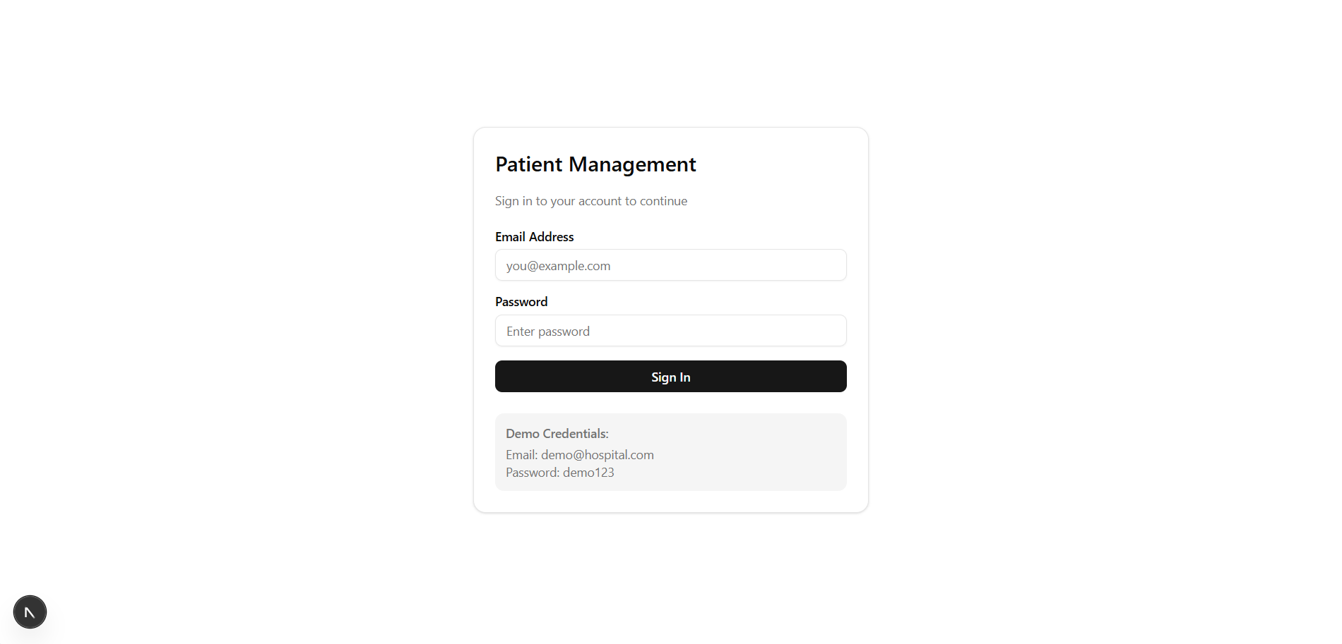
APPENDICES

Figure A1: Login Page
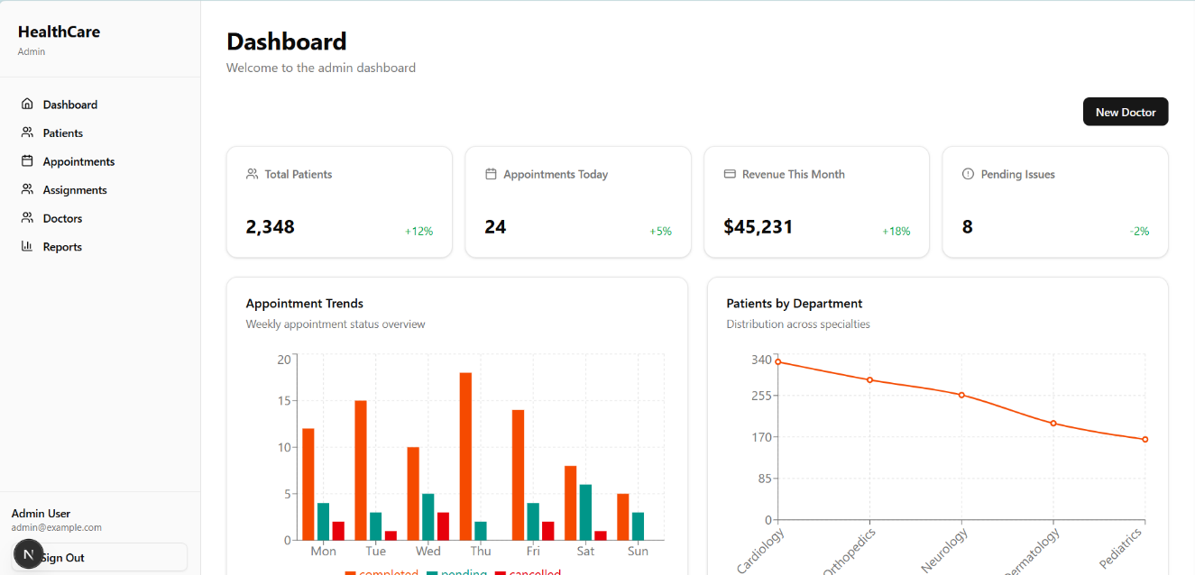

Figure A2: Admine Dashboard

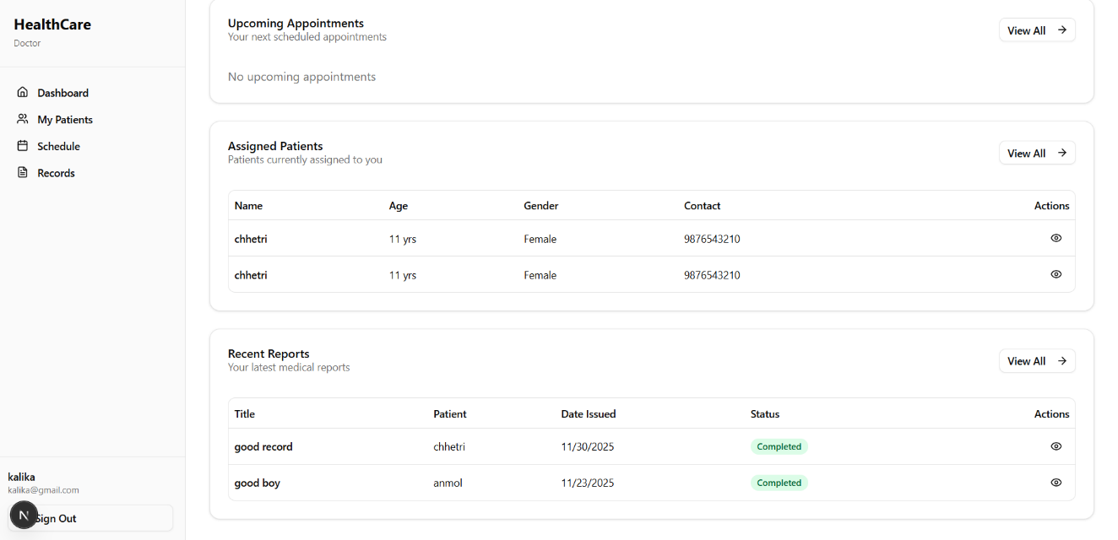
Figure A3: Doctor Record Pannel
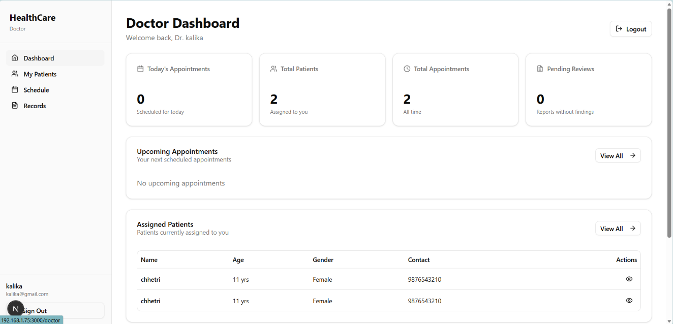

Figure A4: Doctor Dashboard

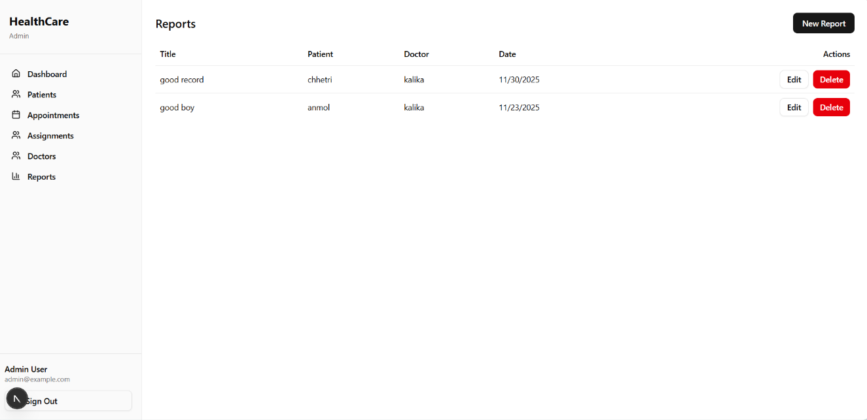

Figure A5:Admine Reports Panel
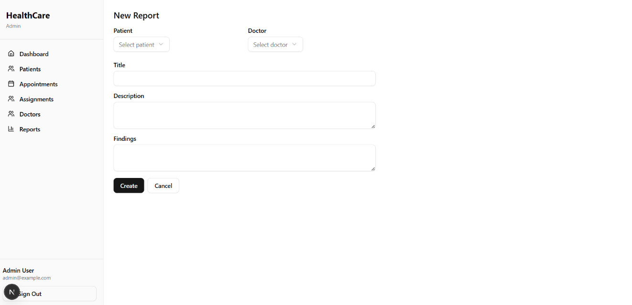

Figure A6:Admine Reports Panel

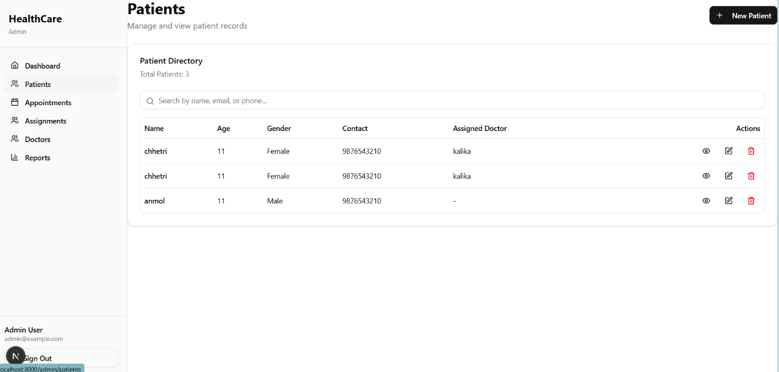

Figure A7:Admine Patients Panel
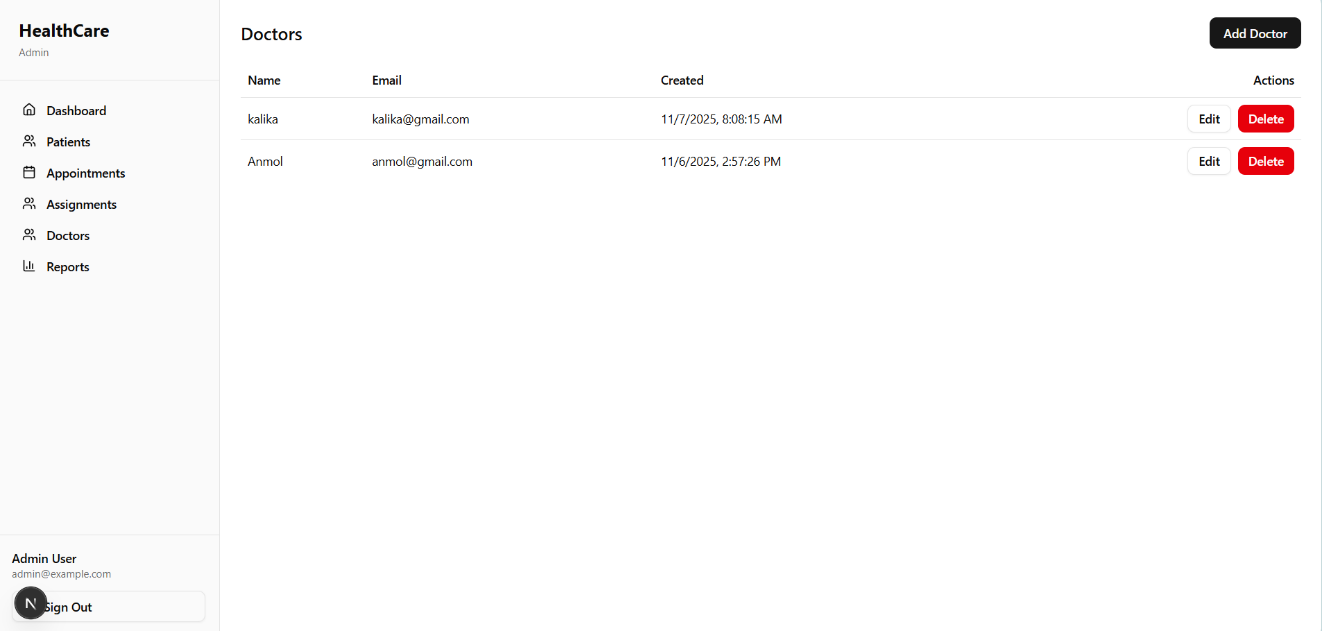

Figure A8:Admine Doctor Panel

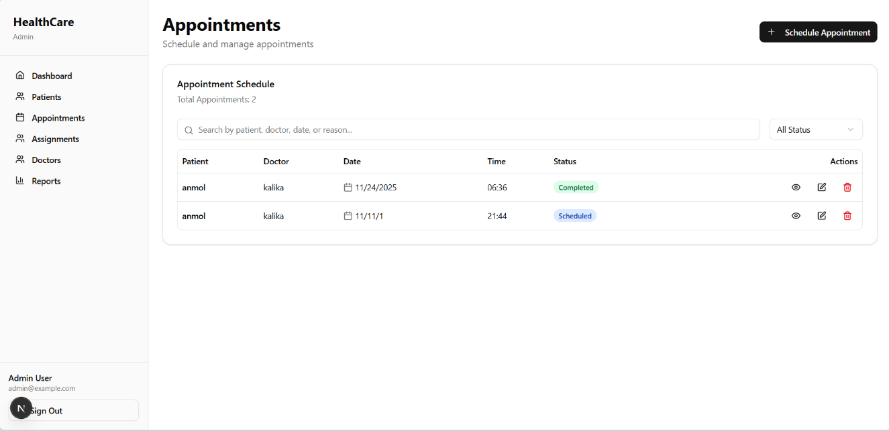

Figure A9:Admine Appointments Panel

